Source Data Mapping Approach to CDMV6.0

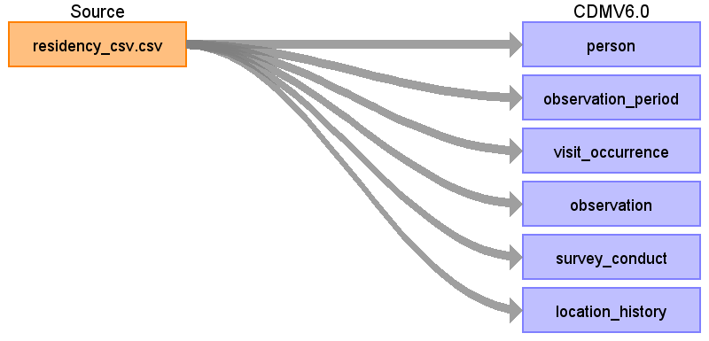

Table name: person

Reading from residency_csv.csv

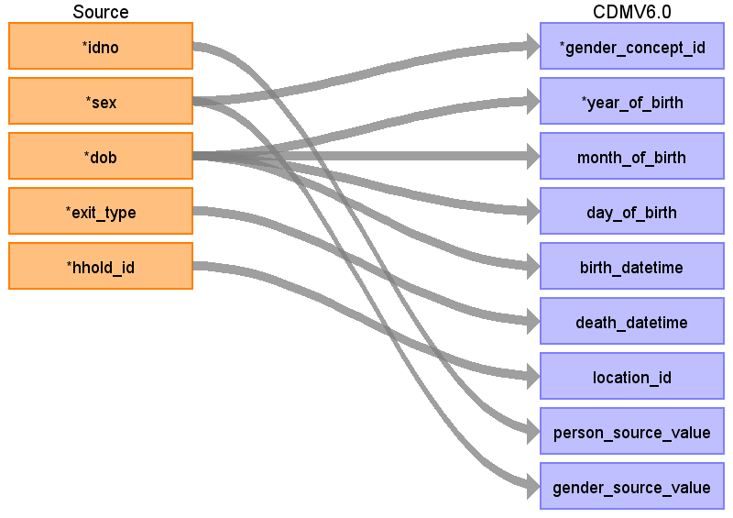

|  |  |  |  |
| --- | --- | --- | --- |
| Destination Field | Source Field | Logic | Comment |
| person_id |  |  |  |
| gender_concept_id | sex |  |  |
| year_of_birth | dob |  |  |
| month_of_birth | dob |  |  |
| day_of_birth | dob |  |  |
| birth_datetime | dob |  |  |
| death_datetime | exit_type |  |  |
| race_concept_id |  |  |  |
| ethnicity_concept_id |  |  |  |
| location_id | hhold_id |  |  |
| provider_id |  |  |  |
| care_site_id |  |  |  |
| person_source_value | idno |  |  |
| gender_source_value | sex |  |  |
| gender_source_concept_id |  |  |  |
| race_source_value |  |  |  |
| race_source_concept_id |  |  |  |
| ethnicity_source_value |  |  |  |
| ethnicity_source_concept_id |  |  |  |

Table name: observation_period

Reading from residency_csv.csv

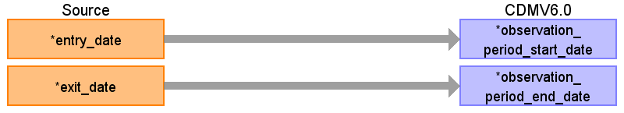

|  |  |  |  |
| --- | --- | --- | --- |
| Destination Field | Source Field | Logic | Comment |
| observation_period_id |  |  |  |
| person_id |  |  |  |
| observation_period_start_date | entry_date |  |  |
| observation_period_end_date | exit_date |  |  |
| period_type_concept_id |  |  |  |

Table name: visit_occurrence

Reading from residency_csv.csv

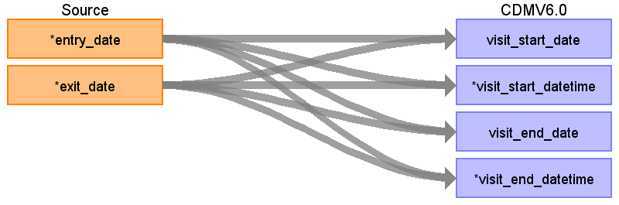

|  |  |  |  |
| --- | --- | --- | --- |
| Destination Field | Source Field | Logic | Comment |
| visit_occurrence_id |  |  |  |
| person_id |  |  |  |
| visit_concept_id |  |  |  |
| visit_start_date | entry_date  exit_date |  |  |
| visit_start_datetime | entry_date  exit_date |  |  |
| visit_end_date | exit_date  entry_date |  |  |
| visit_end_datetime | exit_date  entry_date |  |  |
| visit_type_concept_id |  |  |  |
| provider_id |  |  |  |
| care_site_id |  |  |  |
| visit_source_value |  |  |  |
| visit_source_concept_id |  |  |  |
| admitting_source_concept_id |  |  |  |
| admitting_source_value |  |  |  |
| discharge_to_concept_id |  |  |  |
| discharge_to_source_value |  |  |  |
| preceding_visit_occurrence_id |  |  |  |

Table name: observation

Reading from residency_csv.csv

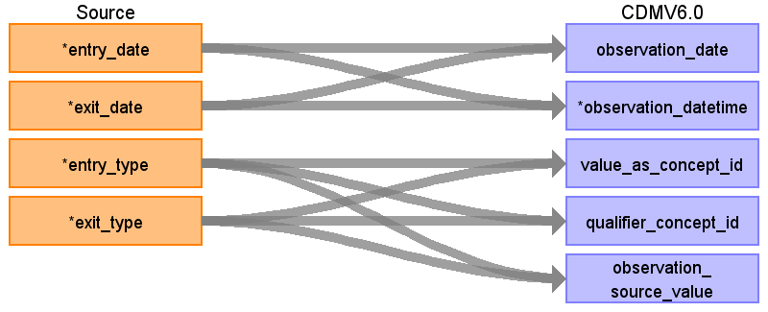

|  |  |  |  |
| --- | --- | --- | --- |
| Destination Field | Source Field | Logic | Comment |
| observation_id |  |  |  |
| person_id |  |  |  |
| observation_concept_id |  |  |  |
| observation_date | entry_date  exit_date |  |  |
| observation_datetime | entry_date  exit_date |  |  |
| observation_type_concept_id |  |  |  |
| value_as_number |  |  |  |
| value_as_string |  |  |  |
| value_as_concept_id | entry_type  exit_type |  |  |
| qualifier_concept_id | entry_type  exit_type |  |  |
| unit_concept_id |  |  |  |
| provider_id |  |  |  |
| visit_occurrence_id |  |  |  |
| visit_detail_id |  |  |  |
| observation_source_value | entry_type  exit_type |  |  |
| observation_source_concept_id |  |  |  |
| unit_source_value |  |  |  |
| qualifier_source_value |  |  |  |
| observation_event_id |  |  |  |
| obs_event_field_concept_id |  |  |  |
| value_as_datetime |  |  |  |

Table name: survey_conduct

Reading from residency_csv.csv

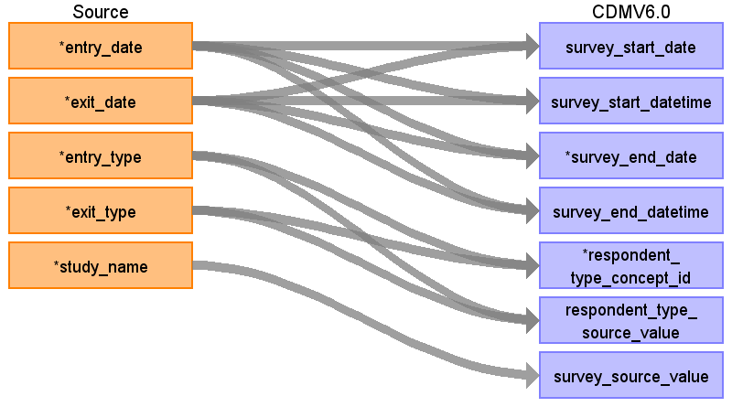

|  |  |  |  |
| --- | --- | --- | --- |
| Destination Field | Source Field | Logic | Comment |
| survey_conduct_id |  |  |  |
| person_id |  |  |  |
| survey_concept_id |  |  |  |
| survey_start_date | entry_date  exit_date |  |  |
| survey_start_datetime | entry_date  exit_date |  |  |
| survey_end_date | exit_date  entry_date |  |  |
| survey_end_datetime | exit_date  entry_date |  |  |
| provider_id |  |  |  |
| assisted_concept_id |  |  |  |
| respondent_type_concept_id | entry_type  exit_type |  |  |
| timing_concept_id |  |  |  |
| collection_method_concept_id |  |  |  |
| assisted_source_value |  |  |  |
| respondent_type_source_value | entry_type  exit_type |  |  |
| timing_source_value |  |  |  |
| collection_method_source_value |  |  |  |
| survey_source_value | study_name |  |  |
| survey_source_concept_id |  |  |  |
| survey_source_identifier |  |  |  |
| validated_survey_concept_id |  |  |  |
| validated_survey_source_value |  |  |  |
| survey_version_number |  |  |  |
| visit_occurrence_id |  |  |  |
| response_visit_occurrence_id |  |  |  |

Table name: location_history

Reading from residency_csv.csv

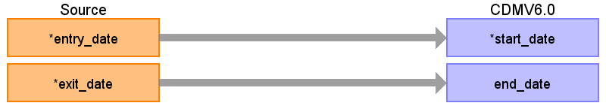

|  |  |  |  |
| --- | --- | --- | --- |
| Destination Field | Source Field | Logic | Comment |
| location_id |  |  |  |
| relationship_type_concept_id |  |  |  |
| domain_id |  |  |  |
| entity_id |  |  |  |
| start_date | entry_date |  |  |
| end_date | exit_date |  |  |